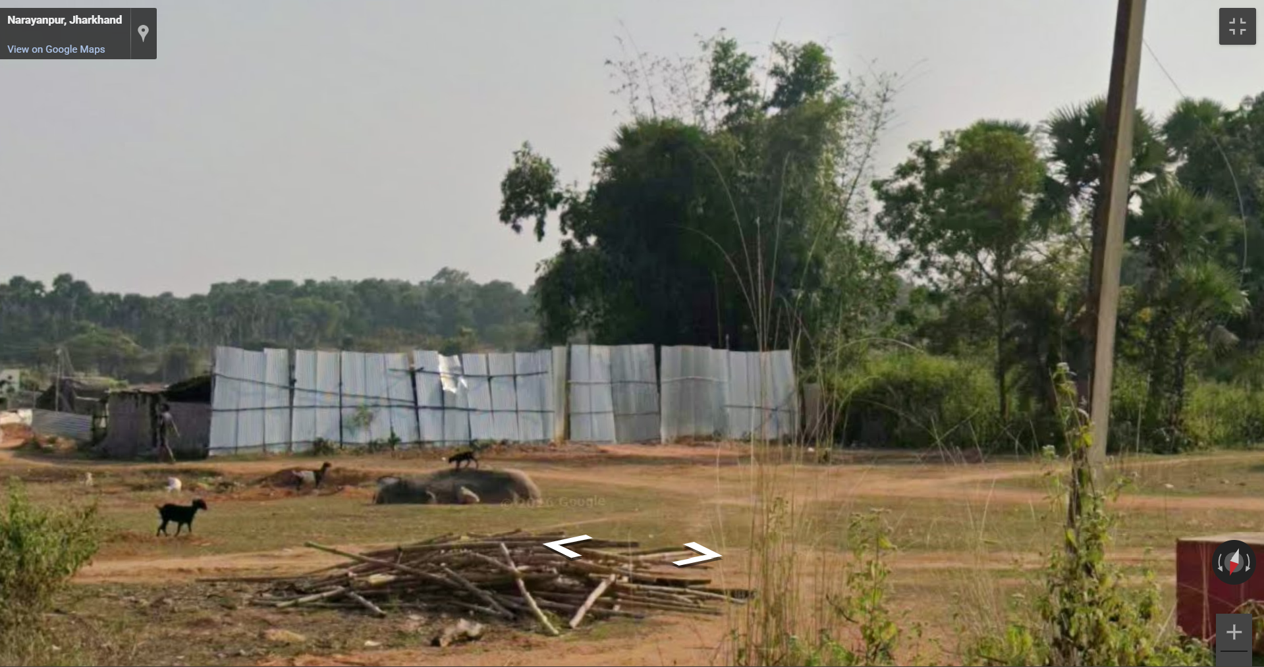

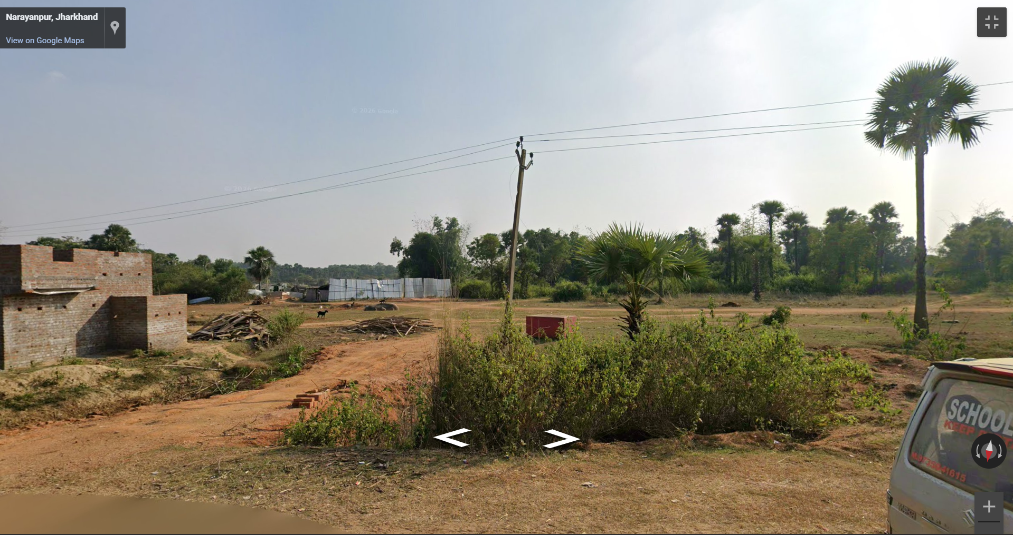

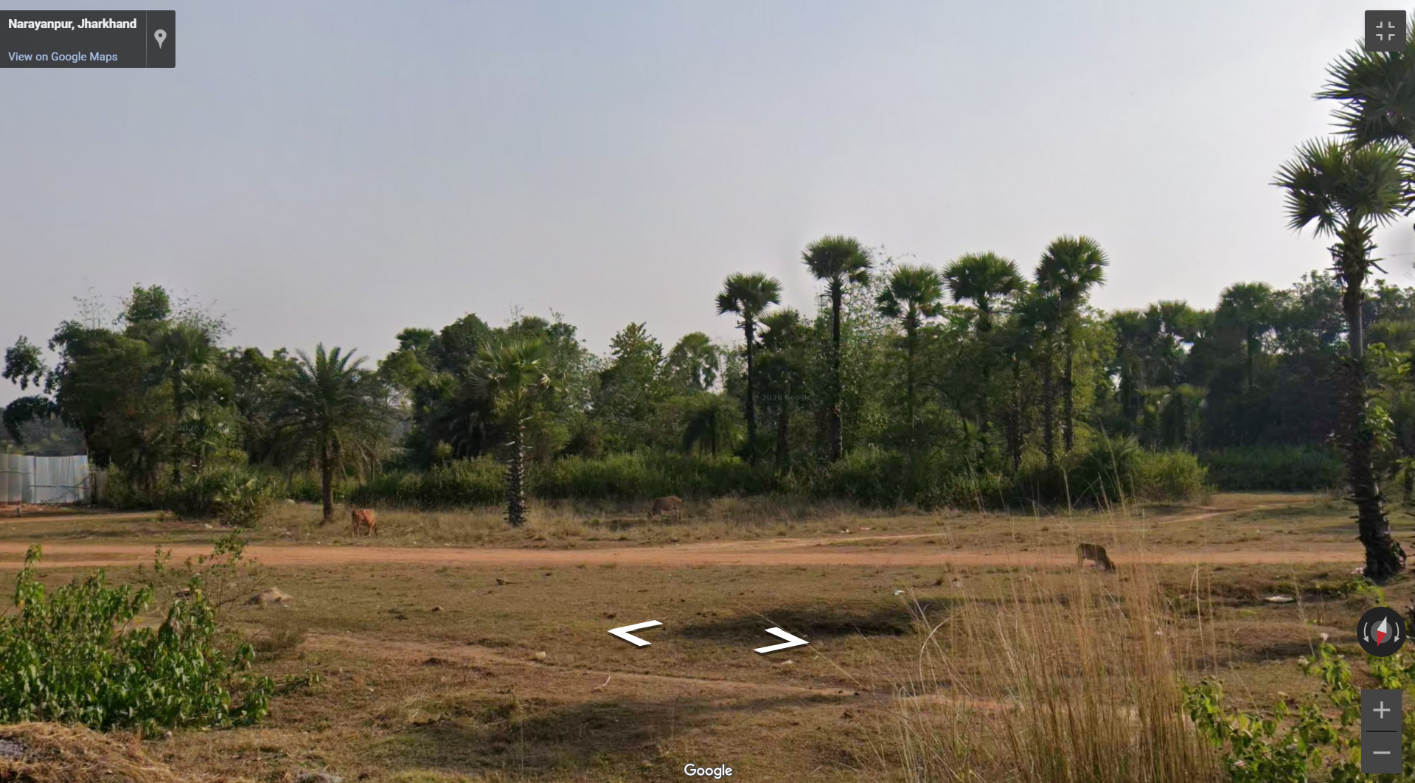

<iframe src="https://www.google.com/maps/embed?pb=!4v1783235142685!6m8!1m7!1sl08B9wtsk-S6rFhP9xghow!2m2!1d24.03901578039266!2d87.38063136856233!3f165.5227164399143!4f-1.3445533294863878!5f3.325193203789971" width="600" height="450" style="border:0;" allowfullscreen="" loading="lazy" referrerpolicy="strict-origin-when-cross-origin"></iframe>

